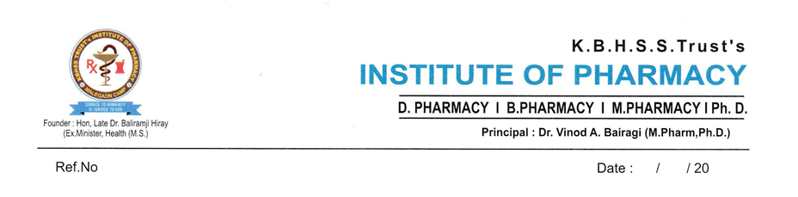

INNOVATIONS BY THE FACULTY IN TEACHING AND LEARNING

ICT Teaching
- Blogs created by faculties
- YouTube Channel
- Working Models
- College magazine and Newsletter
Contributions to teaching and learning are activities that improve student learning. These activities may include innovations and contributions to teaching and learning satisfied following criteria.
- The work made available on Institute website and the internet world
- The work available for peer review and critique
- The work is reproducible
With an aim of innovative teaching and learning process, teachers have adopted newer and different techniques.
Peer Review Process:
The institution has established a systematic peer review process to ensure the quality, relevance, and effectiveness of faculty-developed YouTube videos and teaching models in alignment with NBA requirements.
Step 1: Development
Faculty members develop educational YouTube videos and/or innovative teaching models based on the course curriculum and intended learning outcomes.
Step 2: Submission
The developed content is submitted to the Head of the Department (HoD) along with the title, objectives, Course Outcome (CO) mapping, and other relevant details.
Step 3: Peer Review Committee
A Peer Review Committee comprising three members (Subject Expert, Senior Faculty Member, and NBA Coordinator/Academic Expert) reviews the submitted material.
Step 4: Evaluation
The committee evaluates the content using a structured rubric based on:
- Technical accuracy
- CO/PO mapping
- Innovation and creativity
- Educational value
- Content organization and presentation
- Other quality parameters
Step 5: Review Comments
The committee provides constructive feedback highlighting:
- Strengths of the content
- Areas requiring improvement
- Suggestions for enhancing quality and effectiveness
Step 6: Revision (If Required)
If revisions are recommended, the faculty member incorporates the suggested changes and resubmits the revised content for review.
Step 7: Final Approval
Once the committee is satisfied that all recommendations have been addressed, the Head of the Department grants final approval.
Step 8: Implementation
The approved YouTube videos are uploaded to the institutional or faculty YouTube channel, and the teaching models are utilized in classroom teaching, laboratory demonstrations, and student learning activities.
Step 9: Feedback and Impact Analysis
Student feedback is collected to evaluate the effectiveness of the teaching resource. The impact on student learning, engagement, and attainment of Course Outcomes is analyzed for continuous improvement.
Step 10: Documentation and Record Keeping
All relevant documents, including review forms, evaluation reports, feedback records, approval documents, and evidence of implementation, are maintained for NBA accreditation, quality assurance, and future reference.
Outcome:
This peer review process ensures that faculty-developed educational resources are technically accurate, pedagogically effective, outcome-based, and continuously improved, thereby enhancing the quality of teaching and learning.
A flow chart of the Peer Review process is given below,
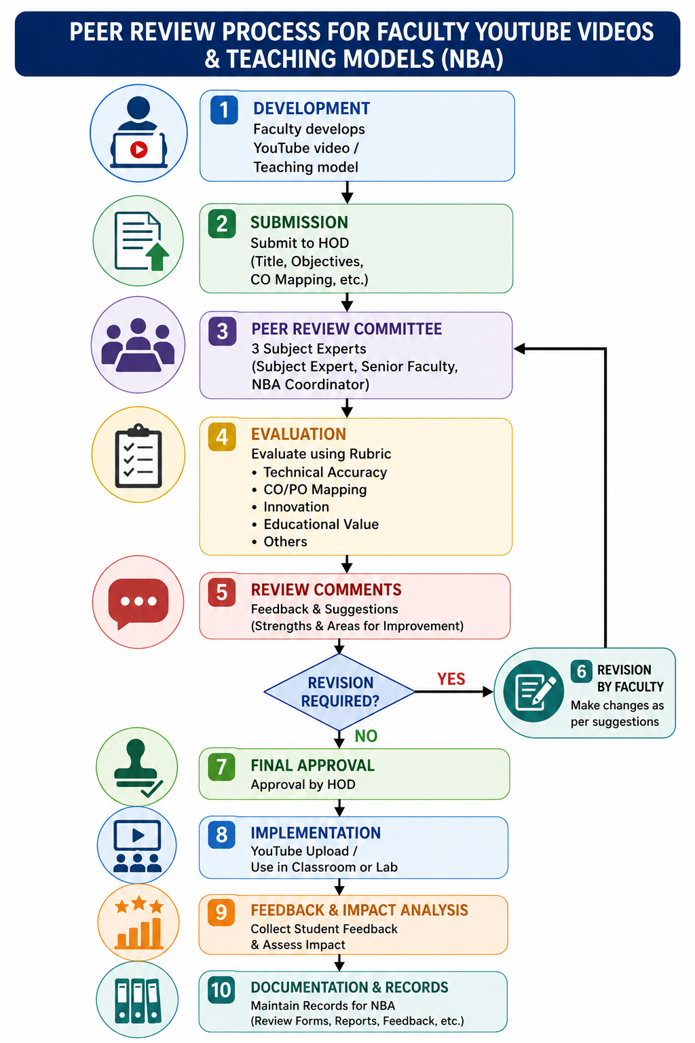

ICT Teaching: ICT opens up opportunities for learning because it enables to learners to access, extend, transform, and share ideas in multi-modal communication forms. Faculty members are constantly encouraged to update their ICT skills using ICT-based teaching methodology.
Blogs created by faculty: Faculty-created blogs serve as an effective academic resource for students by providing subject-related articles, practical insights, case studies, pharmaceutical updates, and learning materials. These blogs contribute to the attainment of several Pharmacy Program Outcomes (POs).
Table 1: List of Blogs created by faculty
Sr. No. | Name of Faculty | Blog link | QR code
1. | Dr Imran Mohammed | https://imransa99.blogspot.com/ | 
2. | Dr. Amol Shirode | https://easychem23.blogspot.com/2026/06/some-practice-questions-for.html | 

YouTube Channel: Faculty creates YouTube channel & upload several videos, animated videos & ppt for students to watch & learn to prepare for their respective course. Few links of you tube channels with their QR codes.
Table 2: You Tube Channel link and QR code.

Sr. No. | Name of Faculty | You Tube Channel Link | QR Code
1 | Mr. R. Y. Pagar | https://www.youtube.com/channel/UCPOzOxRZxnBux1nom9G3qtA | 
2 | Mr. Parag Pathade | https://www.youtube.com/channel/UCK2yy9aUIccN5lqNY08ZL-g | 
3 | Dr. Md. Imran | https://www.youtube.com/channel/UCL8HIdGdpnxq4YdrzV0z4Iw | 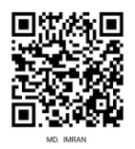
4 | Mr. Sagar Kasar | https://www.youtube.com/user/sagark25nov | 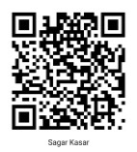
5 | Mr. Pravin Jadhav | https://youtube.com/playlist?list=PL1cFulyuM6dYx0EyiFZy2j4TEln0bD6um | 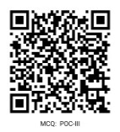
6 | Mr. Amol Shirode | https://www.youtube.com/user/amol254561 | 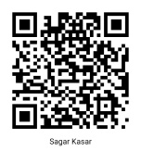
7 | Mr. Yogesh Ahire | https://www.youtube.com/channel/UC5r2llZ3VHf08cBzz_legng/featured | 
8 | Mr. Sandip Ahire | https://youtube.com/@kbhsstsinstituteofpharmacy4398 | 
9 | Mr. Saad Ansari | https://www.youtube.com/@saadthepharmacistacademy2554 | 
10 | Dr. Deepak Somavanshi | https://www.youtube.com/@kbhpharmacognosy | 
11 | Dr. A. B. Gangurde | PowerPoint Presentations: https://www.slideshare.net/AvinashGangurde2016/slideshows | 

Working Models: Faculties developed innovative models in academic year 2023-24, 2024-25, 2025-26 which simplify work or ideas. For all instruments/models, the videos have been prepared explaining the usage of the instrument. QR codes have also been generated for the videos which are available for ready reference.

Table 3: Models
Academic Year 2024-25
Faculty Name: Dr. S. B. Ahire
Title of Innovative Teaching Method | Melt Solidification Apparatus for Pastilles Formulation
Area of Implementation | Subject
Formulation development  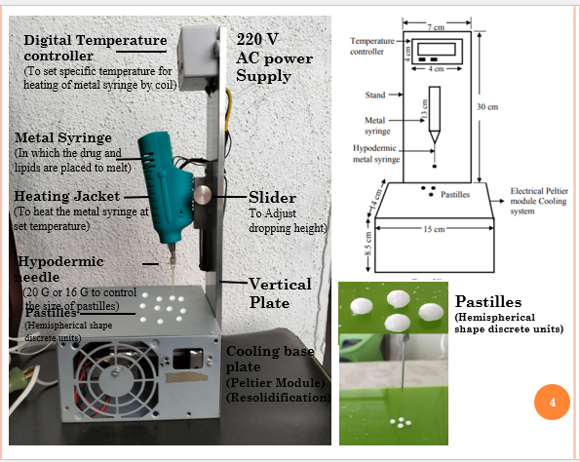 | Pharmaceutics
 | Purpose: This setup is used for the preparation of pharmaceutical pastilles (lozenges) by controlling the temperature of the molten medicated mass and forming uniform hemispherical units through a dropping mechanism. | Applications for B. Pharmacy Students: The device is a laboratory-scale system used to prepare uniform pharmaceutical pastilles by controlled heating, dropping, and cooling of medicated molten mass, helping B. Pharmacy students understand modern dosage form manufacturing techniques.
Faculty Name: Dr. Y.S. Ahire
Title of Innovative Teaching Method | Working of a metabolic cage used for laboratory animals in pharmacology research.
Area of Implementation | Subject
Pharmacology practical’s 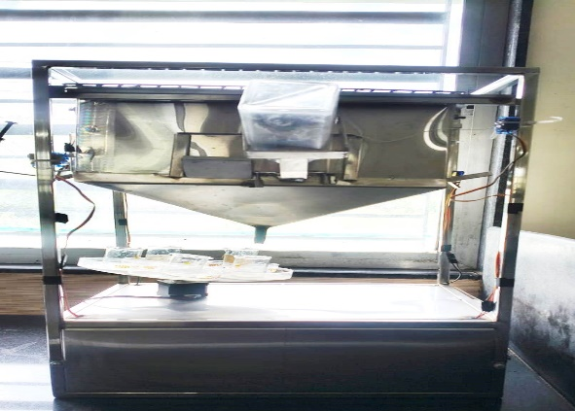 | Pharmacology
 | Aim: To demonstrate the working of a metabolic cage used for laboratory animals in pharmacology research.  Principle:  A metabolic cage is designed to house a single laboratory animal (rat or mouse) while allowing separate collection of urine and feces without contamination. It helps in accurately measuring metabolic parameters during pharmacological experiments. | Applications  - Drug metabolism and excretion studies.  - Diuretic activity evaluation.  - Nephroprotective and nephrotoxicity studies.  - Toxicological investigations.  - Urine output measurement.  - Renal function assessment.  - Pharmacokinetic and bioavailability studies.
Faculty Name: Mr. Y. S. Ahire
Title of Innovative teaching method | Working model of Human Heart
Area of Implementation | Subject
HAP Practical  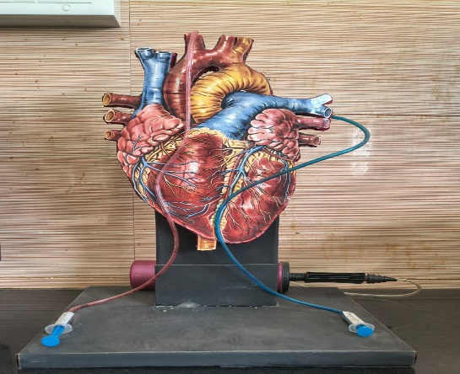 | - Human Anatomy and Physiology
 | Purpose: To demonstrate the structure and blood circulation of the human heart.  Materials Used: Cardboard, plastic heart model, PVC tubes, syringes, colored water (red and blue), adhesive, and stand. | Working Principle: Syringes act as pumps to move colored water through tubes, representing the flow of oxygenated (red) and deoxygenated (blue) blood.  Educational Value: Helps students understand heart anatomy, blood circulation, and the pumping action in an interactive way.
2018-2022
Faculty Name: Mr. S. B. Ahire
Title of Innovative teaching method | Develop Advanced Titration assembly with inbuilt magnetic stirrer
Area of Implementation | Subject
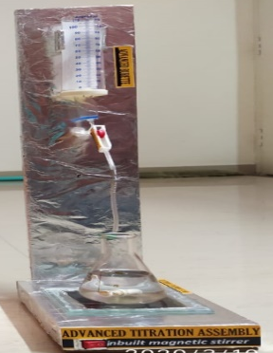  Practical: In regular practical’s  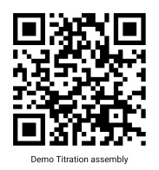 | - Pharmaceutical Chemistry  - Physical Pharmaceutics
 | Conventional titration assembly requires burette stand with clamps, glass burette and Magnetic stirrer difficult to arrange assembly. | Advanced assembly is set of all in one combo help students do practical easily.
Title of Innovative teaching method | Develop Ampule filling and sealing machine
Area of Implementation | Subject
Practical  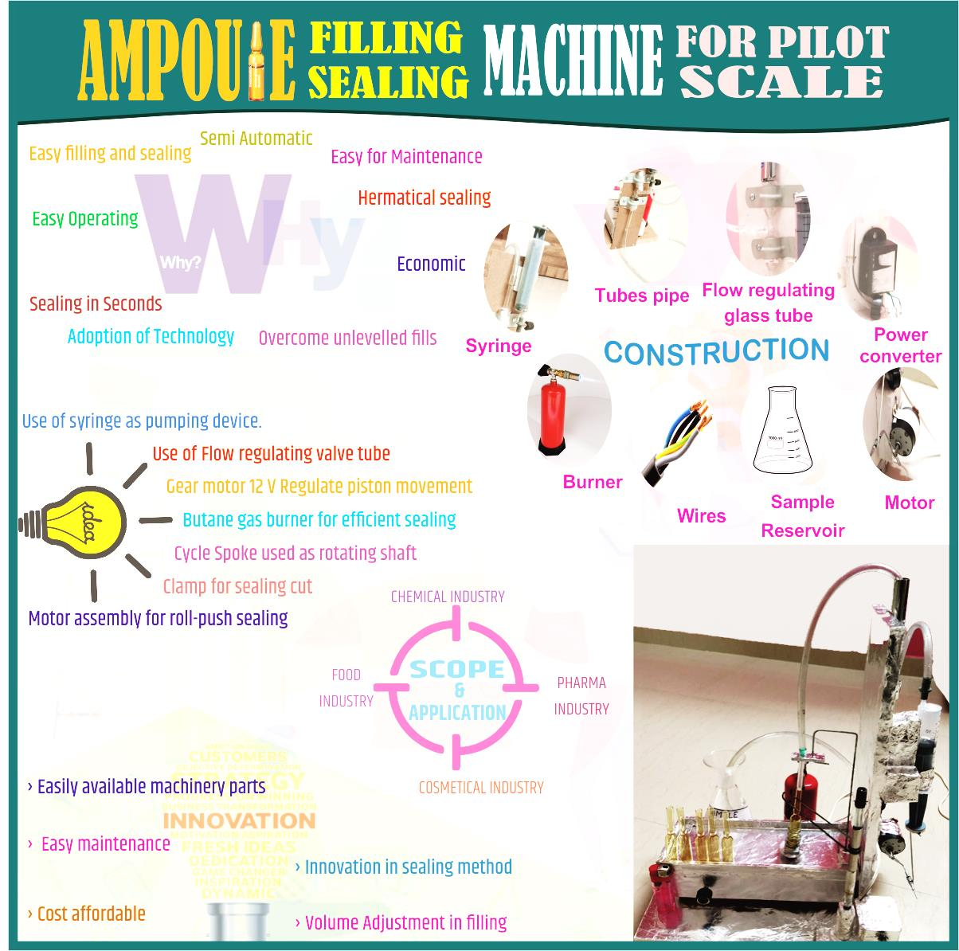 | - Sterile product technology
 | Conventional method is filling ampulemanually with syringe and sealing is by manually on gas burner. | Ampule filling & sealing is done by mechanically syringe and sealing.
Title of Innovative teaching method | Develop Innovative 3D teaching module for video demonstrative practical’s of life sciences field of study: 3D Hologram
Area of Implementation | Subject
Practical :Demonstrative video of working of heart, lungs, kidney, skeleton, eye etc.  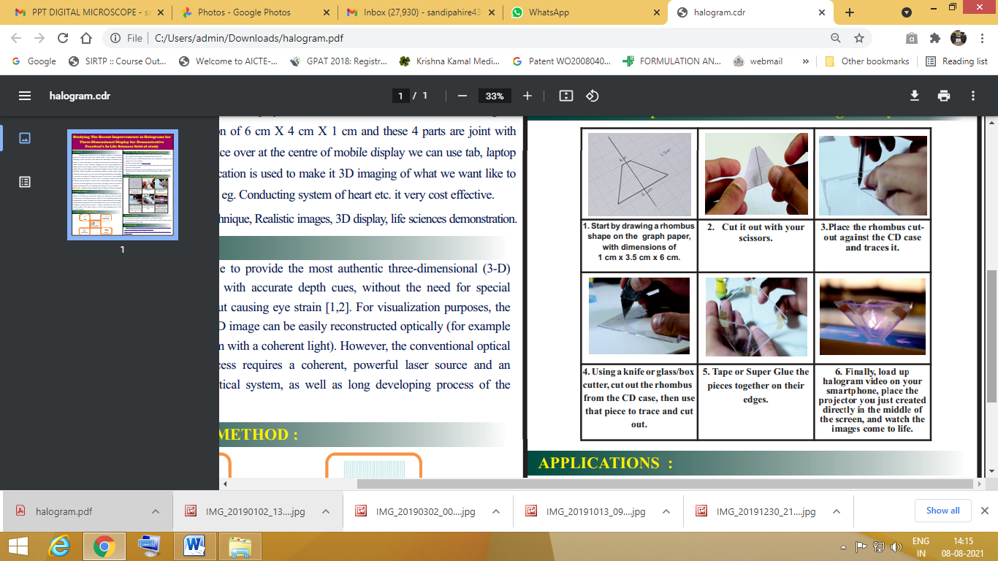  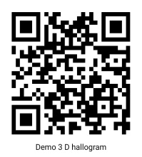 | - Human Anatomy and Physiology
 | Conventional method is show videos one dimensional. | Possible to show video in 3Dimentional.

